1. There may be a number of microservices like now we have 🡺 Currency Exchange, Currency Conversion, Limits Microserivces.
2. These microservices may have a lot of common features such as
   1. Authentication,
   2. Authorization,
   3. Loggings,
   4. Rate Limiting  
      Where to implement these common features instead of repeating them.
3. The typical solution is API Gateway.
   1. In earlier version of Spring Boot, Zuul was used but now Spring Cloud API Gateway.
4. Let’s see how to implement Spring Cloud Gateway and look at the features provided by it.
5. Let’s create a Project for Spring Cloud API Gateway Project.
6. 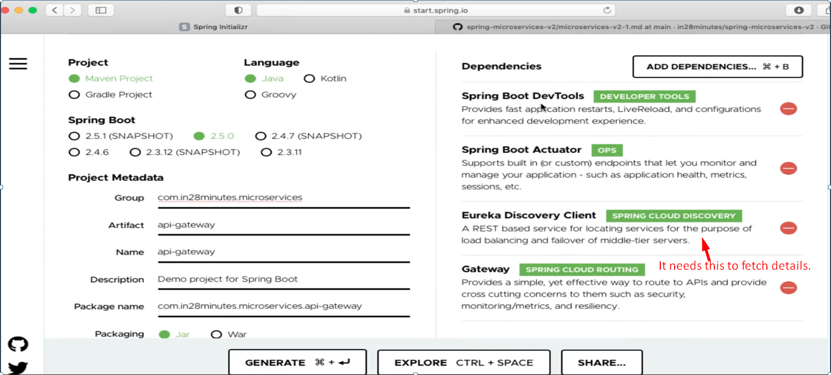
7. Let’s configure inside application.properties.  
   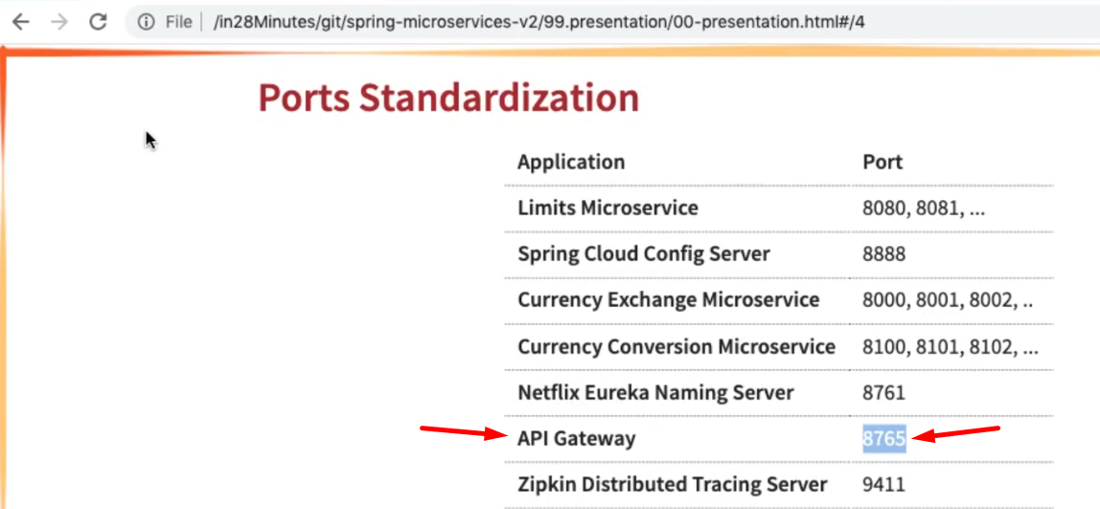
8. 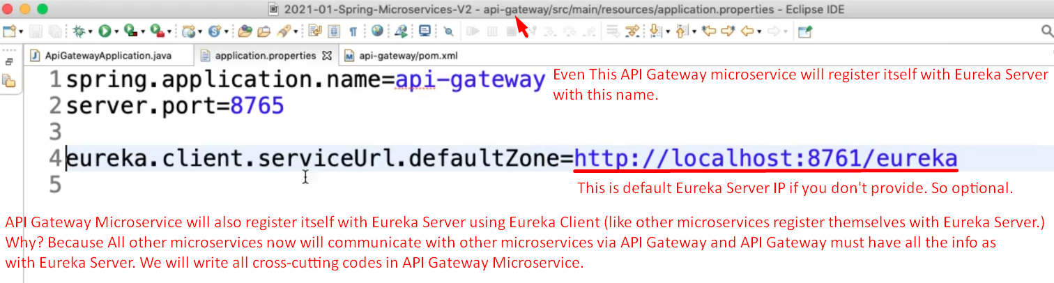
9. 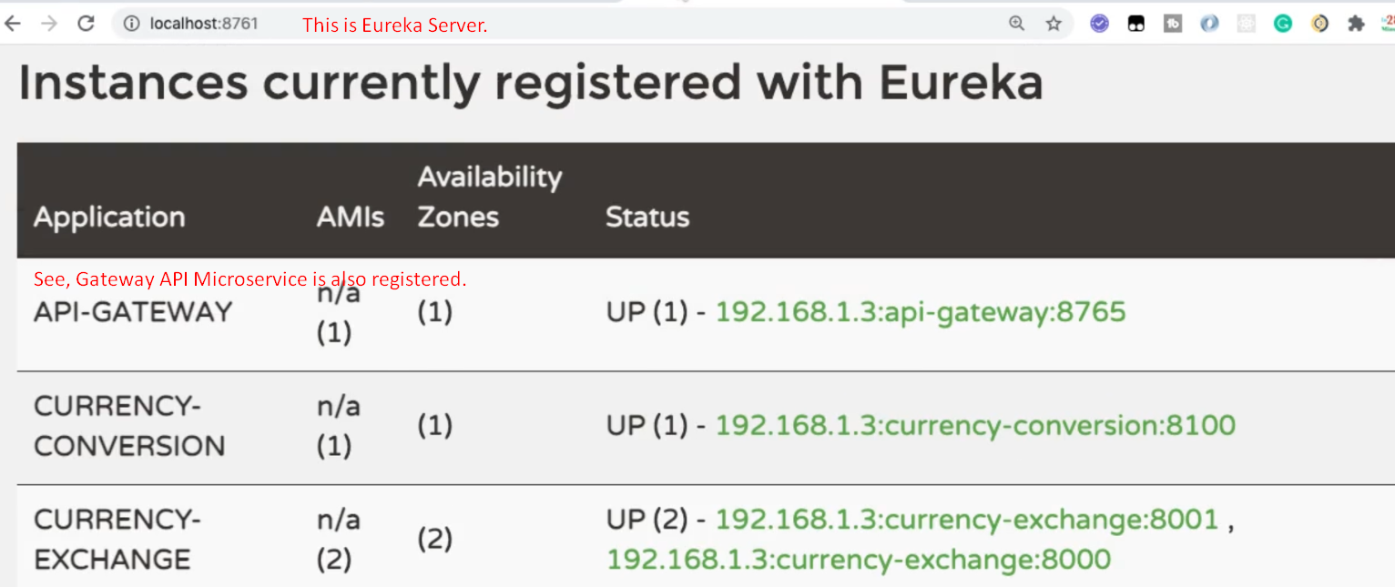
10. Let’s play with API Gateway Microservice in subsequent Lectures.